Ref No: RS_CC_DECTECH_V1.0 Date: 07 Jul 2026


Requirements Specification
(DECTECH to SAS Viya4 API Changes – Personal Loan Process)

Newgen Software Technologies Ltd.
New Delhi, INDIA

RS Document for PL Changes related to SAS API
- This RS is to specify technical changes related to change of API for Personal loan from Current DECTECH API to SAS Viya4 API.
- There are no functional change applicable with this Integration Change.
- Currently DECTECH API is called for credit policy.
- Changes in integration will be done at System Integration WS and Exceptions workstep WS for both the Onboard Journey and Credit Limit Increase Journey
- With this change SAS Viya4 API for Credit Policy will be called at the same stages in the workflow.
  - Automatically at System Integration workstep
  - On Demand on click of ‘Re-Run Policy Check’ button at Exceptions workstep.
- No new field will be added for the purpose of this integration change.
- There will be one to one mapping of the Existing DECTECH API tag with the new SAS Viya4 API tags.

Screenshots for the Trigger points of the API:
1.Exception workstep - On Demand on click of ‘Re-Run Policy Check’ button

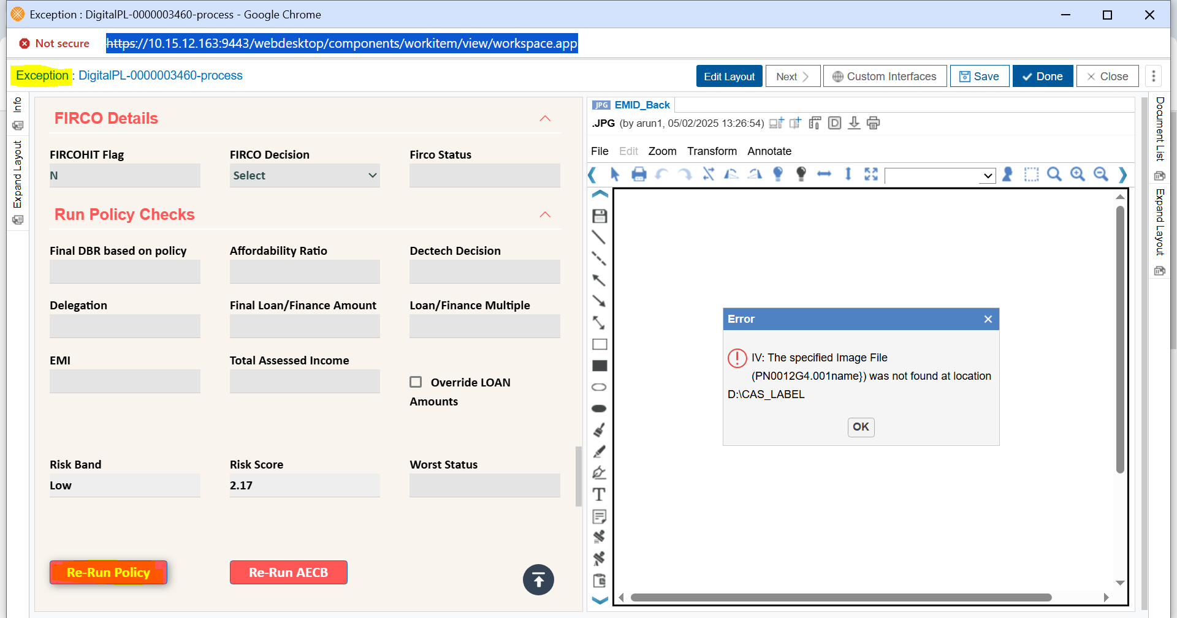

2.Automatically at the System Integration Workstep – This is a system-driven workstep where a backend utility automatically picks up and processes the case. No manual intervention is required at this stage. All fields will be disabled, and users will not have any access rights to view, modify, or perform any actions on the case.
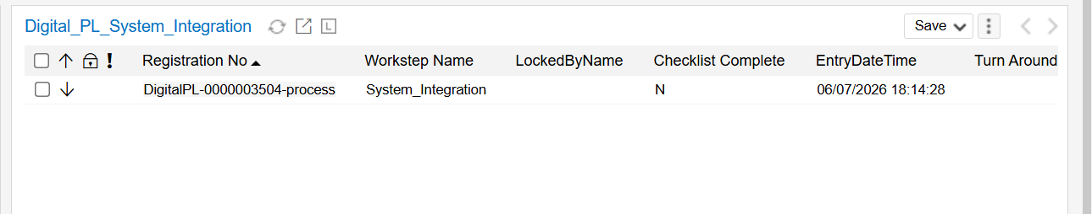

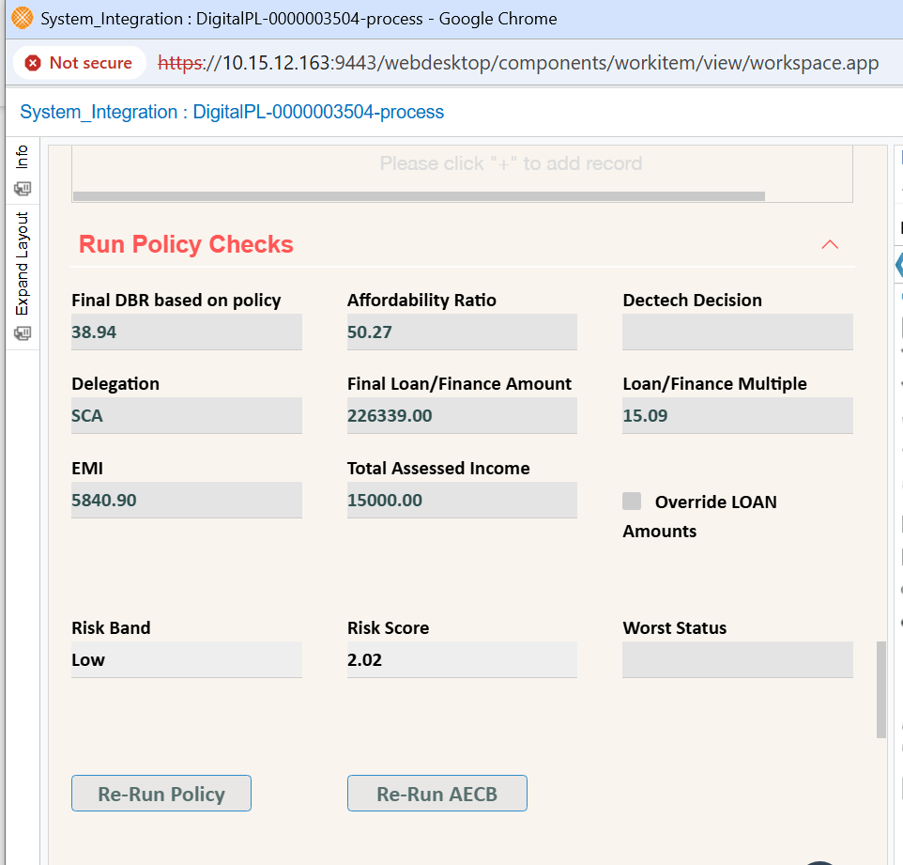

Request Tags mapping between DECTECH API and SAS Viya4 API
SAS API Tag | Existing/New | Corresponding DECTECH API Tag | is Being sent from iBPS in DECTECH API
processManagerRequest | Existing | ProcessManagerRequest | Y
application
channel | Existing | Channel | Y
callType | Existing | CallType | Y
applicationNumber | Existing | ApplicationNumber | Y
requestFrom | Existing | Request_From | Y
custDeclaredNationality | Existing | Cust_Declared_Nationality | Y
cif | New |  | N
agreementId | New |  | N
applicationDetails
fullEligibilityAvailed | Existing | full_eligibility_availed | Y
productType | Existing | product_type | Y
appCategory | Existing | app_category | Y
requestedProduct | Existing | requested_product | Y
requestedLimit | Existing | requested_limit | Y
subProduct | Existing | sub_product | Y
requestedCardProduct | Existing | requested_card_product | N
applicationType | Existing | application_type | Y
tenure | Existing | tenure | Y
interestRate | Existing | interest_rate | Y
customerType | Existing | customer_type | Y
finalLimit | Existing | final_limit | Y
emi | Existing | emi | Y
manualDeviation | Existing | manual_deviation | Y
moratoriumDays | Existing | Moratorium_days | Y
applicationDate | Existing | application_date | Y
salesAgentCode | Existing | sales_agent_code | Y
ccBundleLimit | New |  | N
applicationDateNew | New |  | N
applicantDetails
applicantId | Existing | applicant_id | Y
primaryCif | Existing | primary_cif | N
refNo | Existing | ref_no | Y
wiName | Existing | wi_name | Y
custName | Existing | cust_name | Y
empType | Existing | emp_type | Y
dob | Existing | dob | Y
age | Existing | age | N
nationality | Existing | nationality | Y
residentFlag | Existing | resident_flag | Y
worldCheck | Existing | world_check | Y
los | Existing | los | Y
targetSegmentCode | Existing | target_segment_code | Y
currentEmpCatogery | Existing | current_emp_catogery | Y
designation | Existing | designation | Y
gender | Existing | gender | Y
custMobileNo | Existing | cust_mobile_no | Y
empName | Existing | emp_name | Y
empCode | Existing | emp_code | N
typeOfCompany | Existing | type_of_company | N
industrySector | Existing | industry_sector | N
industryMacro | Existing | industry_macro | N
industryMicro | Existing | industry_micro | N
ccEmployerStatus | New |  | N
plEmployerStatus | New |  | N
ces | New |  | N
includedPlAloc | New |  | N
includedCcAloc | New |  | N
countryOfResidence | Existing | country_of_residence | Y
gccNational | Existing | gcc_national | Y
companyType | Existing | company_type | Y
freezoneComp | New |  | N
aecbConsent | Existing | aecb_consent | Y
noOfDependants | Existing | No_of_dependants | Y
otherHouseholdIncome | Existing | Other_household_income | Y
rakelite | New |  | N
noEarningMembers | Existing | No_earning_members | Y
efrNstp | New |  | N
marketingCode | Existing | marketing_code | Y
payrollFlag | New |  | N
visaIssueDate | Existing | visa_issue_date | Y
visaExpiryDate | Existing | visa_expiry_date | Y
passportExpiryDate | Existing | passport_expiry_date | Y
emiratesVisa | Existing | emirates_visa | Y
noBankOtherStatementProvided | Existing | no_bank_other_statement_provided | Y
plEmployerStatusExpat | New |  | N
plEmployerStatusNational | New |  | N
visaSponsor | Existing | visa_sponsor | Y
salaryWithRakbank | New |  | N
employerContractType | New |  | N
confirmedInJob | New |  | N
internalBureauData
internalBureau
plbScoreRiskRange | New |  | N
companyFlag | Existing | company_flag | Y
internalBouncedCheques
companyFlag | New |  | N
internalBureauIndividualProducts
applicantId | New |  | N
internalBureauIndividualProductsId | New |  | N
grossSalary | New |  | N
cardProduct | New |  | N
phase | New |  | N
generalStatus | New |  | N
contractType | New |  | N
companyFlag | New |  | N
creditLimit | New |  | N
cardsBScore | New |  | N
mob | New |  | N
linkedLiability | New |  | N
considerForObligation | New |  | N
noOfRepaymentsDone | New |  | N
internalBureauPipelineProducts
companyFlag | New |  | N
internalBureauDbRtaiCalc
basic | Existing | basic | Y
grossSalary | Existing | gross_salary | Y
netSalaryMon1 | Existing | net_salary_mon1 | Y
netSalaryMon2 | Existing | net_salary_mon2 | Y
netSalaryMon3 | Existing | net_salary_mon3 | Y
finalUwSalary | New |  | N
accomodationAllowance | New |  | N
accomodationAllowanceDuration | New |  | N
additionalIncomeFlag | New |  | N
cashBonus | New |  | N
cashBonusDuration | New |  | N
educationAllowance | New |  | N
educationAllowanceDuration | New |  | N
flyingAllowance | New |  | N
flyingAllowanceDuration | New |  | N
otherVariableAllowance | New |  | N
otherVariableAllowanceDuration | New |  | N
rentalIncomePl | New |  | N
rentalIncomePlDuration | New |  | N
uwOth | New |  | N
externalBureauData
externalBureau
applicantId | Existing | applicant_id | Y
bureauoneRefNo | Existing | bureauone_ref_no | Y
fullName | Existing | full_name | Y
totalOutBal | Existing | total_out_bal | Y
totalOverdue | Existing | total_overdue | Y
totalExposure | Existing | total_exposure | Y
worstCurrPay | Existing | worst_curr_pay | Y
worstCurrPay24 | Existing | worst_curr_pay_24 | Y
worstStatus24 | New |  | N
chequeReturn3mon | Existing | cheque_return_3mon | Y
ddsReturn3mon | Existing | dds_return_3mon | Y
ddsReturn6mon | New |  | N
chequeReturn6mon | New |  | N
noMonthsAecbHistory | New |  | N
aecbScore | New |  | N
range | New |  | N
aecbEnquiryDate | New |  | N
companyFlag | Existing | company_flag | Y
disputeAlert | Existing | dispute_alert | Y
externalBureauEmploymentDetails
applicantId | New |  | N
employmentName | New |  | N
employmentType | New |  | N
grossAnnualIncome | New |  | N
dateOfEmployment | New |  | N
dateOfTermination | New |  | N
providerNo | New |  | N
dateOfLastUpdate | New |  | N
actualFlag | New |  | N
utilization24months
cbApplicationId | New |  | N
month | New |  | N
creditLimit | New |  | N
outstandingBalance | New |  | N
history24months
cbApplicationId | New |  | N
monthyear | New |  | N
status | New |  | N
externalBureauAccountDetails
applicantId | New |  | N
accountType | New |  | N
phase | New |  | N
iban | New |  | N
cbAccountNo | New |  | N
dpAccountNo | New |  | N
providerNo | New |  | N
startDate | New |  | N
closedDate | New |  | N
dateOfLastUpdate | New |  | N
externalBureauSalaryDetails
applicantId | New |  | N
cbAccountNo | New |  | N
year | New |  | N
month | New |  | N
totalSalaryAmount | New |  | N
noOfSalaryTransferred | New |  | N
externalBureauIndividualProducts
applicantId | New |  | N
externalBureauIndividualProductsId | New |  | N
contractType | New |  | N
providerNo | New |  | N
phase | New |  | N
roleOfCustomer | New |  | N
startDate | New |  | N
closeDate | New |  | N
outstandingBalance | New |  | N
totalAmount | New |  | N
paymentsAmount | New |  | N
totalNoOfInstalments | New |  | N
noOfRemainingInstalments | New |  | N
worstStatus | New |  | N
worstStatusDate | New |  | N
overdueAmount | New |  | N
noOfDaysPaymentDelay | New |  | N
mob | New |  | N
companyFlag | New |  | N
takeOverIndicator | New |  | N
considerForObligation | New |  | N
duplicateFlag | New |  | N
paymentFrequency | New |  | N
creditLimit | New |  | N
lastRepaymentDate | New |  | N
currentlyCurrent | New |  | N
dpd5pInLast12Mon | New |  | N
dpd30Last6Mon | New |  | N
dpd60pInLast12Mon | New |  | N
noMonthsAecbHistory | New |  | N
maximumOverdueAmount | New |  | N
delinquentInLast3Months | New |  | N
maximumOverdueDate | New |  | N
statementDueAmount | New |  | N
externalBureauPipelineProducts
applicantId | New |  | N
externalBureauPipelineProductsId | New |  | N
pplProviderNo | New |  | N
pplTypeOfContract | New |  | N
pplTypeOfProduct | New |  | N
pplPhase | New |  | N
pplRole | New |  | N
pplDateOfLastUpdate | New |  | N
pplTotalAmount | New |  | N
pplNoOfInstalments | New |  | N
pplNoOfDaysInPipeline | New |  | N
pplConsiderForObligation | New |  | N
pplDuplicateFlag | New |  | N
pplCreditLimit | New |  | N
companyFlag | New |  | N
externalBouncedCheques
applicantId | New |  | N
externalBouncedChequesId | New |  | N
bouncedCheque | New |  | N
chequeNo | New |  | N
amount | New |  | N
reason | New |  | N
returnDate | New |  | N
providerNo | New |  | N
companyFlag | New |  | N
courtCase
codOrganization | New |  | N
providerCaseNo | New |  | N
referenceDate | New |  | N
caseCategoryCode | New |  | N
openDate | New |  | N
closeDate | New |  | N
caseStatusCode | New |  | N
initialTotalClaimAmount | New |  | N
applicantId | New |  | N
perfios
stmtSalary1 | Existing | Stmt_Salary_1 | Y
stmtSalary1Date | Existing | Stmt_salary1_date | Y
stmtSalary2 | Existing | Stmt_salary_2 | Y
stmtSalary2Date | Existing | Stmt_salary2_date | Y
stmtSalary3 | Existing | Stmt_salary_3 | Y
stmtSalary3Date | Existing | Stmt_salary3_date | Y
stmtSalary4 | New |  | N
stmtSalary4Date | New |  | N
stmtSalary5 | New |  | N
stmtSalary5Date | New |  | N
stmtSalary6 | New |  | N
stmtSalary6Date | New |  | N
stmtSalary7 | New |  | N
stmtSalary7Date | New |  | N
addnPerfiosEmi1 | New |  | N
addnPerfiosEmi2 | New |  | N
addnPerfiosEmi3 | New |  | N
addnPerfiosEmi4 | New |  | N
addnPerfiosEmi5 | New |  | N
addnPerfiosEmi6 | New |  | N
jointAcct | New |  | N
highValueDeposit | New |  | N
creditAmount | New |  | N
stmtChqRtnLast3mnts | New |  | N
stmtChqRtnClearedIn30Last3mnts | New |  | N
stmtChqRtnLast1mnt | New |  | N
stmtChqRtnClearedIn30Last1mnt | New |  | N
stmtDdsRtnLast3mnts | New |  | N
stmtDdsRtnClearedIn30Last3mnts | New |  | N
pensioner | New |  | N
nameMatch | Existing | Name_match | Y
fcuIndicator | New |  | N
uwReqd | Existing | UW_reqd | Y
addnPerfiosEmi7 | New |  | N
addnPerfiosEmi8 | New |  | N
addnPerfiosEmi9 | New |  | N
addnPerfiosEmi10 | New |  | N
addnPerfiosEmi11 | New |  | N
addnPerfiosEmi12 | New |  | N
addnPerfiosEmi13 | New |  | N
addnPerfiosEmi14 | New |  | N
addnPerfiosEmi15 | New |  | N
addnPerfiosEmi16 | New |  | N
addnPerfiosEmi17 | New |  | N
addnPerfiosEmi18 | New |  | N
addnPerfiosEmi19 | New |  | N
addnPerfiosEmi20 | New |  | N
addnPerfiosCc | New |  | N
addnPerfiosOdAmt | New |  | N
addnOdDate | New |  | N
stmtDdsRtnLast1mnt | New |  | N
stmtDdsRtnClearedIn30Last1mnts | New |  | N
salWithdrawalCriteriaMet5d | New |  | N
abSalRatioCriteriaMet | New |  | N

Response Tags mapping between DECTECH API and SAS Viya4 API
SAS API Tag | Existing/New | Corresponding DECTECH API Tag | saved in iBPS from DECTECH API
processManagerResponse | Existing | ProcessManagerResponse
application
channel | Existing | Channel
callType | Existing | CallType
applicationNumber | Existing | ApplicationNumber
cif | New
agreementId | New
returnDateTime | Existing | ReturnDateTime
pmResults
dbr | Existing | DBR
reasonCode | New
reasonDescription | New
pmDecisionResultsData
pmDecisionResults
decisionObjective | Existing | Decision_Objective
decisionSequenceNumber | Existing | Decision_Sequence_Number
lastUpdateDate | Existing | Last_Update_Date
defaultDecision | Existing | Default_Decision
defaultReason | Existing | Default_Reason
defaultDocument | Existing | Default_Document
systemDecision | Existing | System_Decision
systemDocument | Existing | System_Document
decisionNodeId | Existing | Decision_Node_Id
decisionTestGroup | Existing | Decision_Test_Group
pmReasonCodesData
pmReasonCodes
decisionObjective | Existing | Decision_Objective
decisionSequenceNumber | Existing | Decision_Sequence_Number
sequenceNumber | Existing | Sequence_Number
reasonDecision | Existing | Reason_Decision
reasonCode | Existing | Reason_Code | Y
reasonDescription | Existing | Reason_Description | Y
criteriaName | Existing | Criteria_Name
letterCode | Existing | Letter_Code
document | Existing | Document
letterReason | Existing | Letter_Reason
name | New
pmOutputs
application
outputAdditionalAmount | Existing | Output_Additional_Amount
outputAecbSalary1 | Existing | Output_AECB_Salary_1 | Y
outputAecbSalary2 | Existing | Output_AECB_Salary_2 | Y
outputAecbSalary3 | Existing | Output_AECB_Salary_3 | Y
outputAecbSalaryEligible | Existing | Output_AECB_Salary_Eligible
outputAffordableEmi | Existing | Output_Affordable_EMI | Y
outputAffordableRatio | Existing | Output_Affordable_Ratio | Y
outputAge | Existing | Output_Age | Y
outputAlternateCard | Existing | Output_Alternate_Card | Y
outputDecision | Existing | Output_Decision | Y
outputDelegationAuthority | Existing | Output_Delegation_Authority | Y
outputEligibleAmount | Existing | Output_Eligible_Amount | Y
outputEligibleCards | Existing | Output_Eligible_Cards | Y
outputEmi | Existing | Output_EMI | Y
outputExistingDbr | Existing | Output_Existing_DBR
outputFinalAmount | Existing | Output_Final_Amount | Y
outputFinalDbr | Existing | Output_Final_DBR | Y
outputInterestRate | Existing | Output_Interest_Rate | Y
outputLoanAmountReleaseFlag | Existing | Output_LoanAmountReleaseFlag
outputMaturityAge | Existing | Output_Maturity_Age | Y
outputNoOfRepaymentsTopup | Existing | Output_no_of_repayments_topup | Y
outputNoOfAecbHistory | Existing | Output_NoOf_AECBHistory | Y
outputNstp | Existing | Output_NSTP | Y
outputPerMonInterest | Existing | Output_PerMon_Interest | Y
outputPlTotalExposure | Existing | Output_PL_total_exposure | Y
outputReferQueue | Existing | Output_Refer_Queue | Y
outputSalTransfer | Existing | Output_Sal_transfer
outputSalaryMultiples | Existing | Output_Salary_Multiples | Y
outputSecCheckReq | Existing | Output_sec_check_Req | Y
outputStl | Existing | Output_STL
outputTai | Existing | Output_TAI | Y
outputTenor | Existing | Output_Tenor | Y
outputTotalDeduction | Existing | Output_TotalDeduction | Y
outputStressDbr | Existing | Output_Stress_DBR | Y

API COMPARISON BETWEEN SAS AND DECTECH:

